**AWS Task-2**

**Task Description:**

Set up a VPC with an Internet gateway, create a public subnet with 256 IP addresses, a private subnet with 256 IP addresses, make a route table connecting the Internet gateway and the subnets, and launch a Linux EC2 instance by using the above VPC and public subnet.

**Solution :**

**✅ 1.Create a Virtual Private Cloud (VPC)**

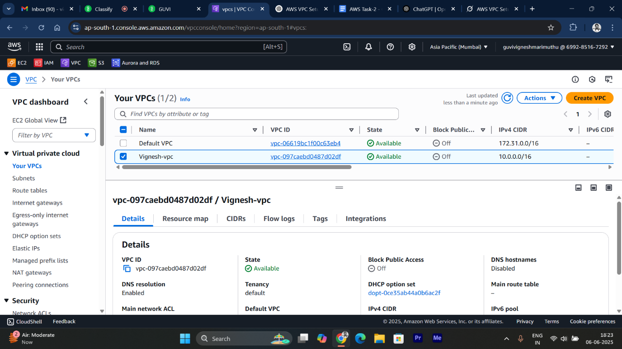

* A **VPC** is a private, isolated section of the AWS Cloud where you can launch AWS resources.
* The CIDR 10.0.0.0/16 provides 65,536 IP addresses, sufficient for two /24 subnets (256 IPs each, with 5 reserved by AWS per subnet).

**✅ 2.Create and Attach an Internet Gateway(IGW)**

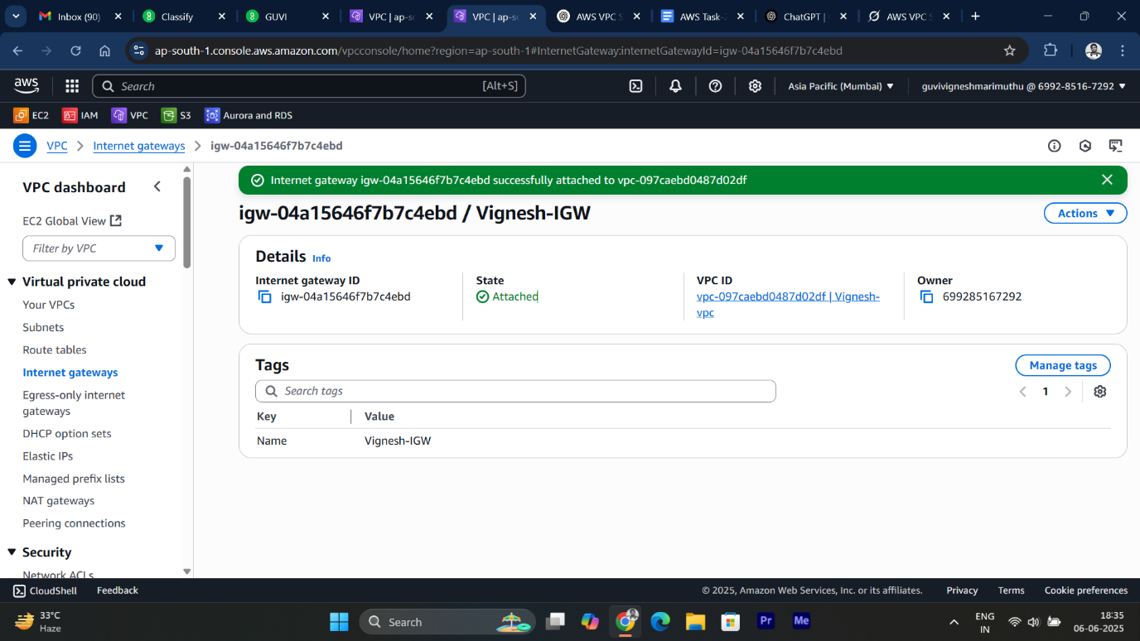

* Enable internet access for the public subnet by attaching an Internet Gateway to the VPC.

**✅ 3.Create Public Subnet**

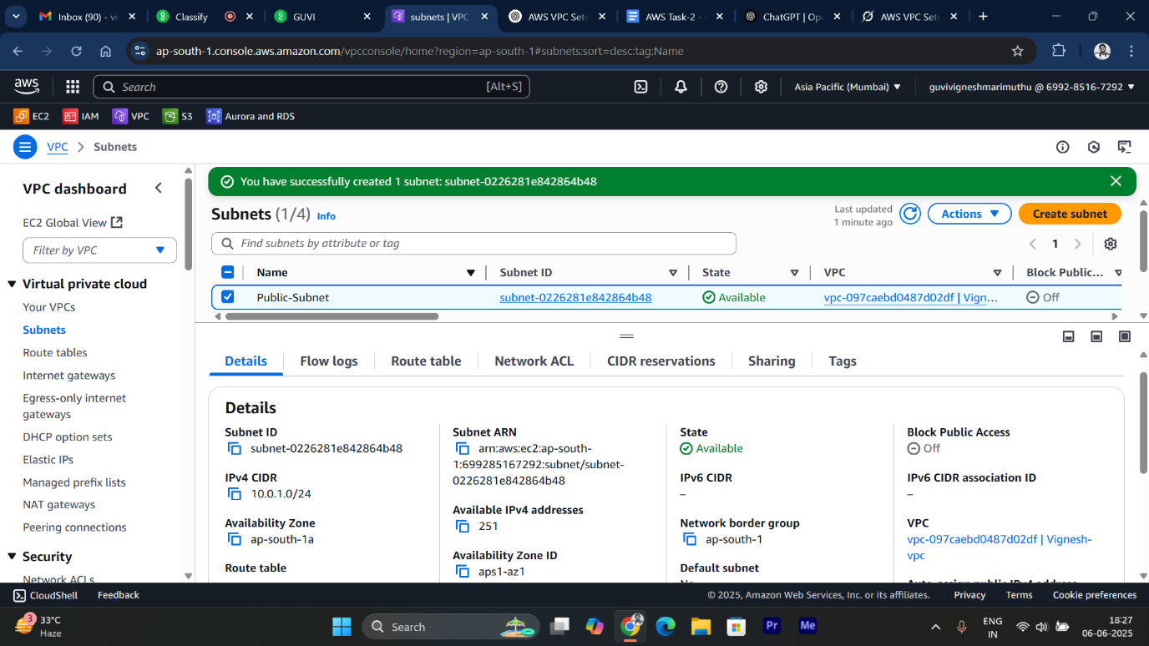

* A **public subnet** allows resources to communicate with the internet.
* The CIDR **10.0.1.0/24** provides 256 IPs (251 usable after AWS reservations).
* The Availability Zone (e.g., us-east-1a) ensures resource placement.

**✅ 4.Create Private Subnet**

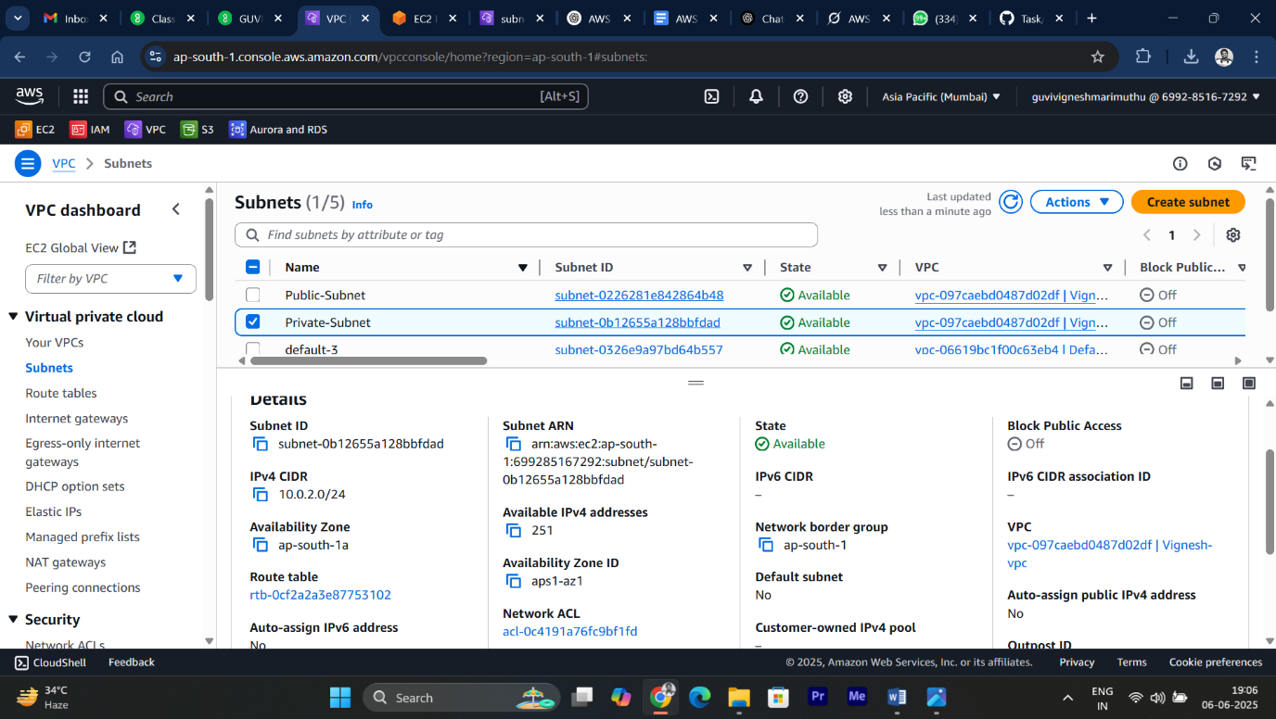

* CIDR **10.0.2.0/24** provides 256 IPs addresses that remains private (no direct internet access).
* The Availability Zone (e.g., us-east-1a) ensures resource placement.

**✅ 5.** **Create and Configure a Route Table**

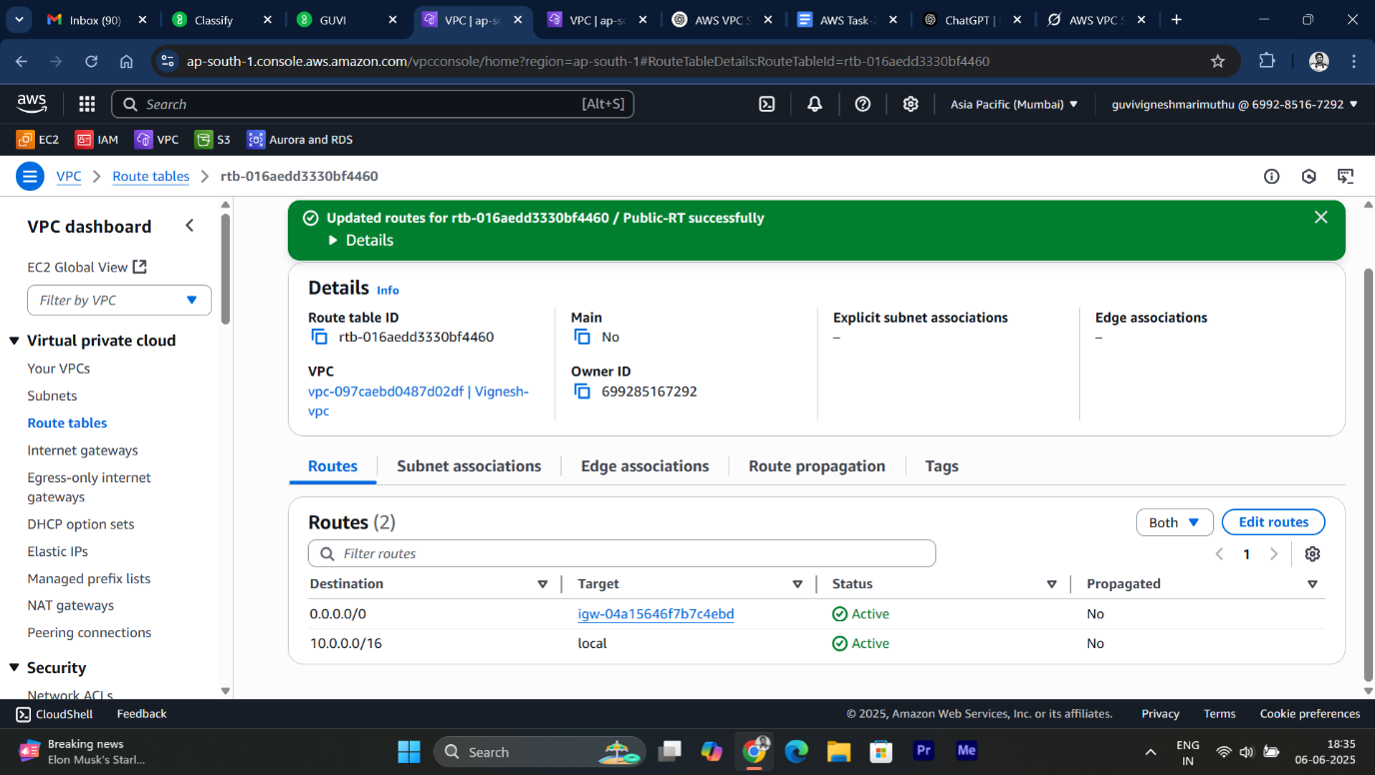

* Create a route table for the public subnet with a route to the Internet Gateway.
* The **0.0.0.0/0** route directs external traffic to the Internet Gateway, making the subnet public. The private subnet uses the default main route table, which has no internet route.

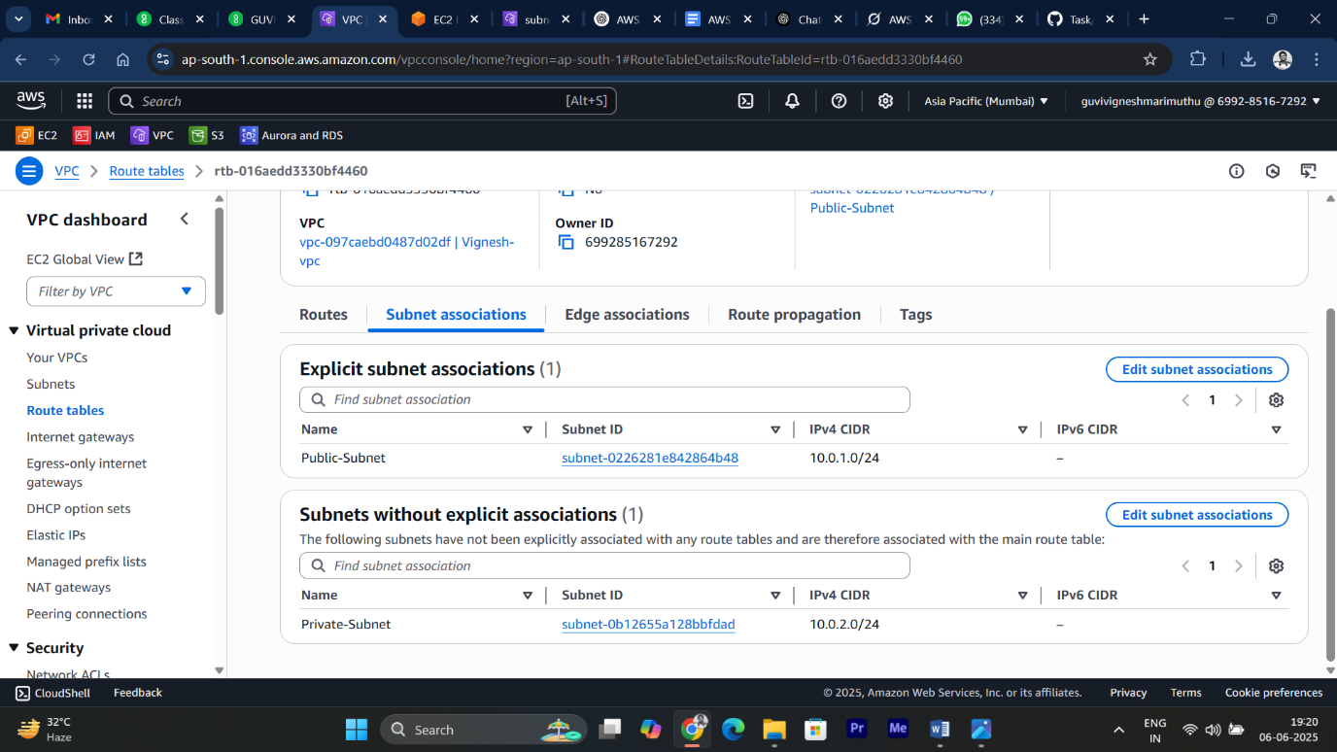

* Associate Public Subnet: **Route Table** that has a route to the **Internet Gateway**.

**✅ 6.Launch Ubuntu EC2 Instance in Public Subnet**

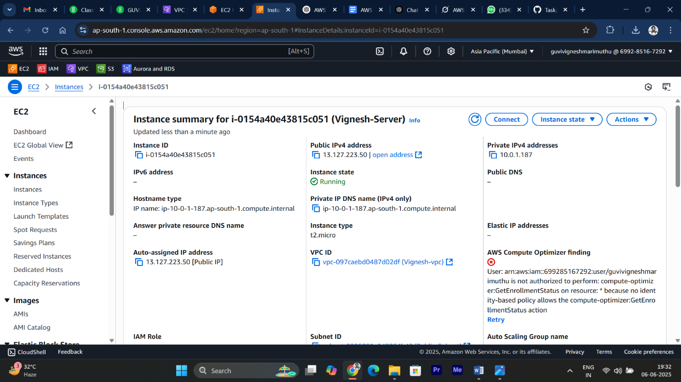

* The **instance** is launched in the **public subnet** ( Within given **CIDR 10.0.1.0/24** ) with a public IP.

**✅ 7.Testing EC2 Internet Access**

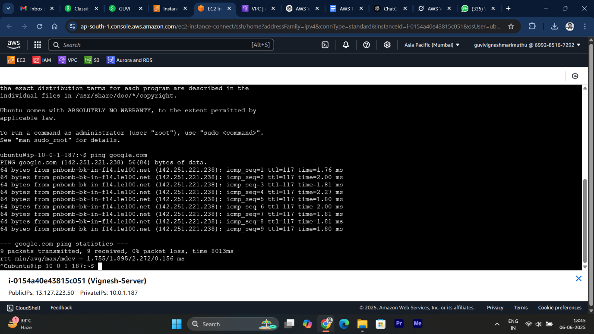

* **ping** is successful → Internet access working!